STEP-1: PUT THIS URL <https://strade.shareindia.com/interactive/thirdparty?&appKey=YOUR_APP_KEY&returnURL=https://Strade.shareindia.com/interactive/testapi>

IN THE BROWSER

STEP:2-ENTER USERID

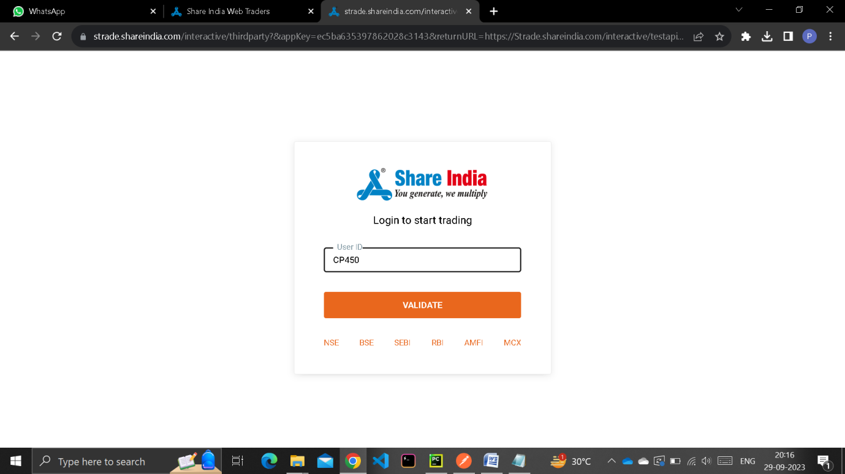

STEP:3- ENTER PASSWORD 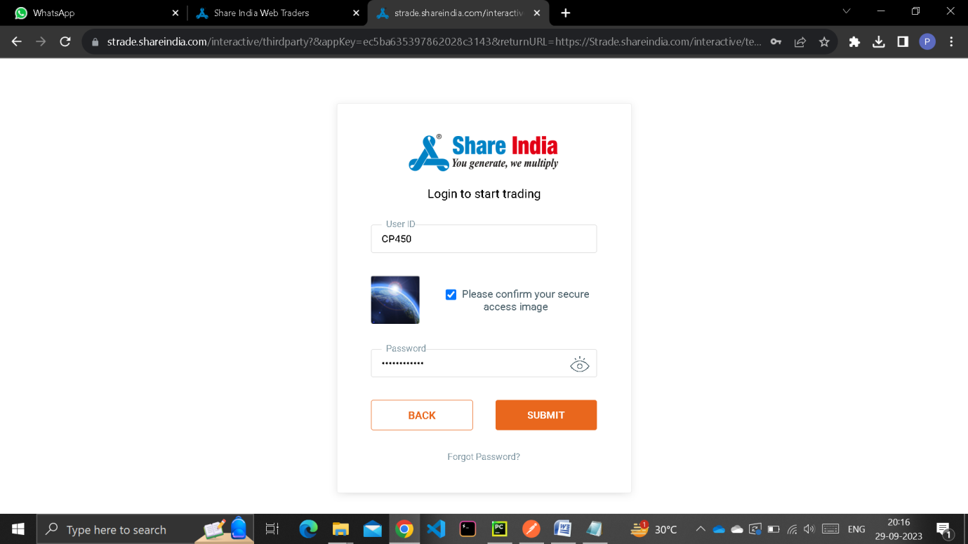

STEP:4-ENTER TOTP

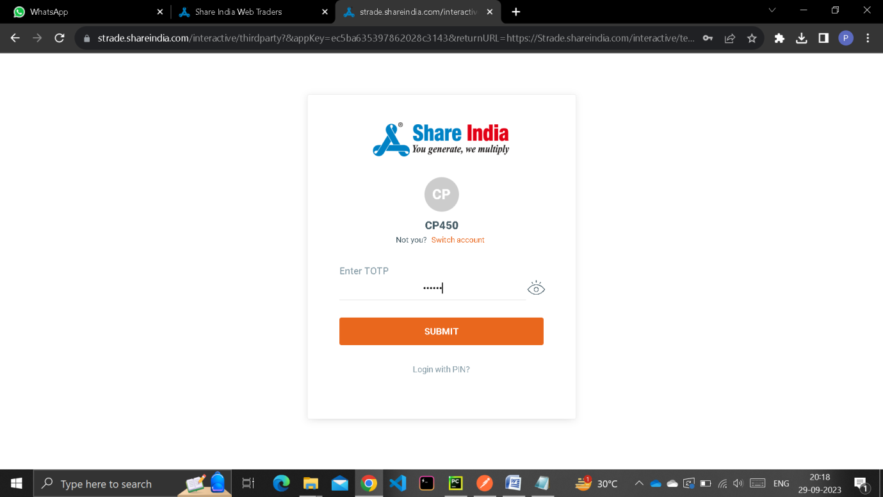

STEP:5-ACCESS TOKEN GENERATED

